**Front-End UI/UX Mini Project**

**1. Title Page**

* **Project Title**: Personal Diary UI
* **Submitted By**: 
  + *Team Members-*

*Karthik Rajeev (2462096)*

Levin Thomas (2462517)

Pagadala Rohith (2462523)

* + *College-E-mailid-*

[*karthik.rajeev@btech.christuniversity.in*](mailto:karthik.rajeev@btech.christuniversity.in)

[*levin.thomas@btech,christuniversity.in*](mailto:levin.thomas@btech,christuniversity.in)

[*pagadala.rohith@btech.christuniversity.in*](mailto:pagadala.rohith@btech.christuniversity.in)

* **Course**: *UI/UX Design Fundamentals*
* **Instructor Name**: *Nagaveena.*
* **Institution**: *Christ University*
* **Date of Submission**: *12/08/2025*

**2. Abstract**

This project presents the design and development of a responsive, aesthetically pleasing online diary named Cool Pastel Diary, created entirely using HTML5 and CSS3.

The aim was to deliver a visually calming, user-friendly interface for daily journaling, featuring editable diary entries, decorative date tabs, and a notebook-like background.

The design focuses on modern pastel tones, semantic HTML structure, and flexible layouts that adapt across desktop, tablet, and mobile devices. No JavaScript or backend integration is included, keeping the application lightweight and easily deployable. The result is a functional digital diary that is visually engaging, responsive, and easy to customize.

**3. Objectives**

* Create a calming, visually appealing diary interface using pastel colors.  
  - Implement a semantic HTML5 structure for clarity and accessibility.  
  - Apply CSS3 for branding, layout, and responsive design.  
  - Enable editable text fields for diary entries without JavaScript.  
  - Ensure usability across desktop, tablet, and mobile devices.

**4. Scope of the Project**

**Scope:**

* Pure front-end design using **HTML5** and **CSS3**.
* Editable text fields for **date**, **title**, and **diary content**.
* Fully responsive design optimized for **desktop, tablet, and mobile viewports**.

**Out of Scope:**

* No JavaScript functionality for saving or storage.
* No server-side processing or database connectivity.
* No third-party UI libraries — entirely custom-coded.

.

**5. Tools & Technologies Used**

|  |  |
| --- | --- |
| Tool/Technology | Purpose |
| HTML5 | Markup and content structure |
| CSS3 | Styling and layout management |
| VS Code | Code editor |
| Chrome DevTools | Testing and debugging |

**6. HTML Structure Overview**

* Used semantic tags: <header>, <nav>, <main>, <section>, <footer>
* Structured into reusable sections: About, Projects, Contact
* Navigation menu using <ul> and anchor links for smooth scrolling

**7. CSS Styling Strategy**

* Used external CSS file (style.css)
* Organized with comments and sections
* Techniques used:
  + Flexbox and Grid for layout
  + Media Queries for responsiveness
  + CSS Variables for theme customization
  + Hover effects and transitions
  + Mobile-first design approach

**8. Key Features**

|  |  |
| --- | --- |
| Feature | Description |
| Responsive Design | Adapts seamlessly to all screen sizes |
| Smooth Navigation | Fixed top nav with anchor links |
| Project Cards | Flex-based layout with hover effects |
| Contact Form (non-functional) | Placeholder layout for inputs and button |
| Accessible Fonts & Colors | High contrast and readable typography |

|  |  |
| --- | --- |
| Challenge | Solution |
| Maintaining layout consistency across different screen sizes | Applied **CSS media queries** for responsive design |
| Difficulty aligning diary input fields and labels | Used **Flexbox** for proper alignment and spacing |
| Text overflowing in diary content area | Implemented **word-wrap** and **text area resizing** |

**9. Challenges Faced & Solutions**

**10. Outcome**

* Achieved a clean, consistent, and visually engaging front-end layout
* All key components function as intended using just HTML and CSS
* Learned about layout responsiveness and UI hierarchy in depth

**11. Future Enhancements:**

* **Add JavaScript for saving and retrieving diary entries locally (e.g., using Local Storage).**
* **Implement search and filter functionality to find specific entries.**
* **Add image upload support to attach photos to diary entries.**
* **Introduce a theme toggler for light/dark modes.**
* **Enable export to PDF for offline backup of diary entries.**

**12. Sample Code**

**PERSONAL DIARY VERSION**

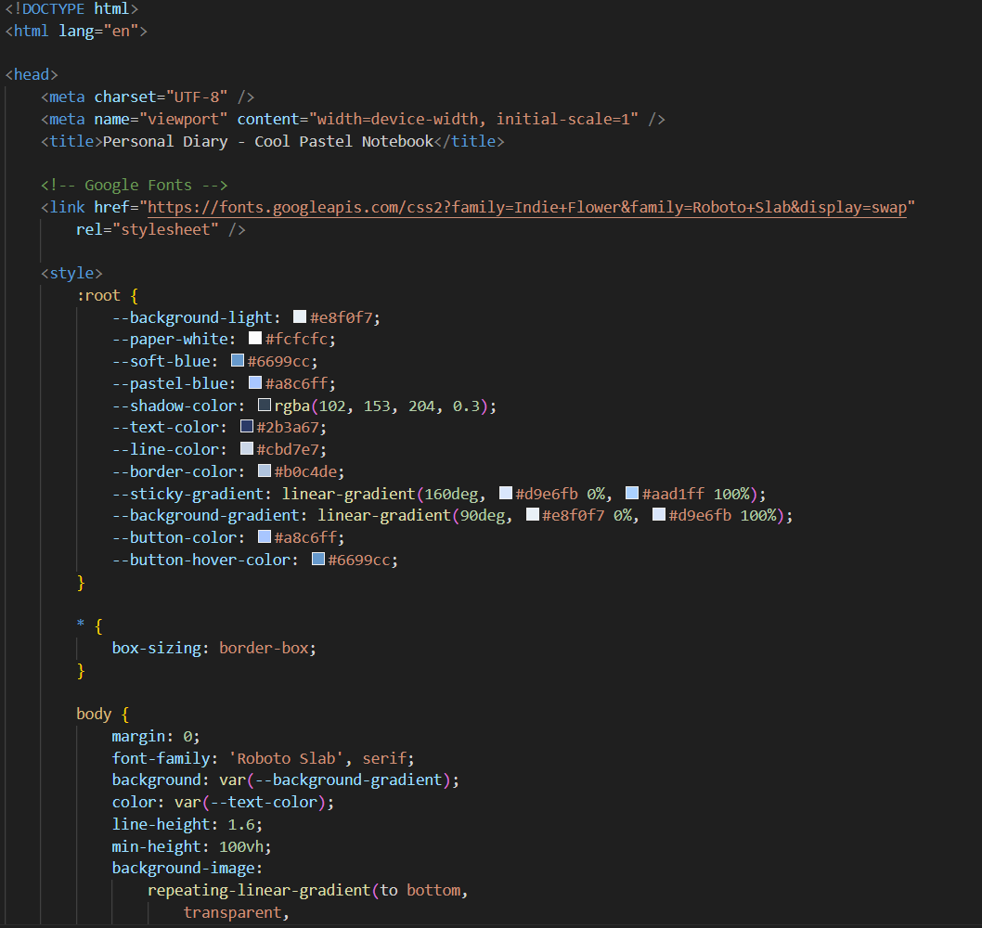

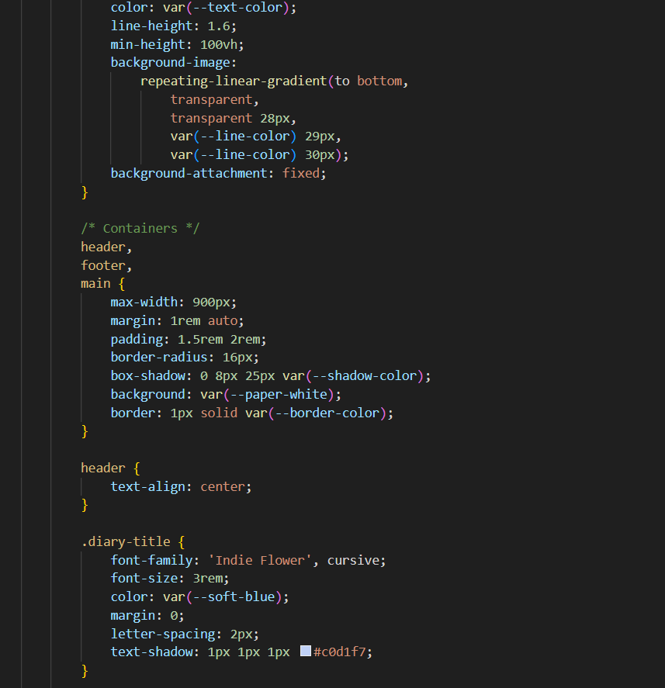

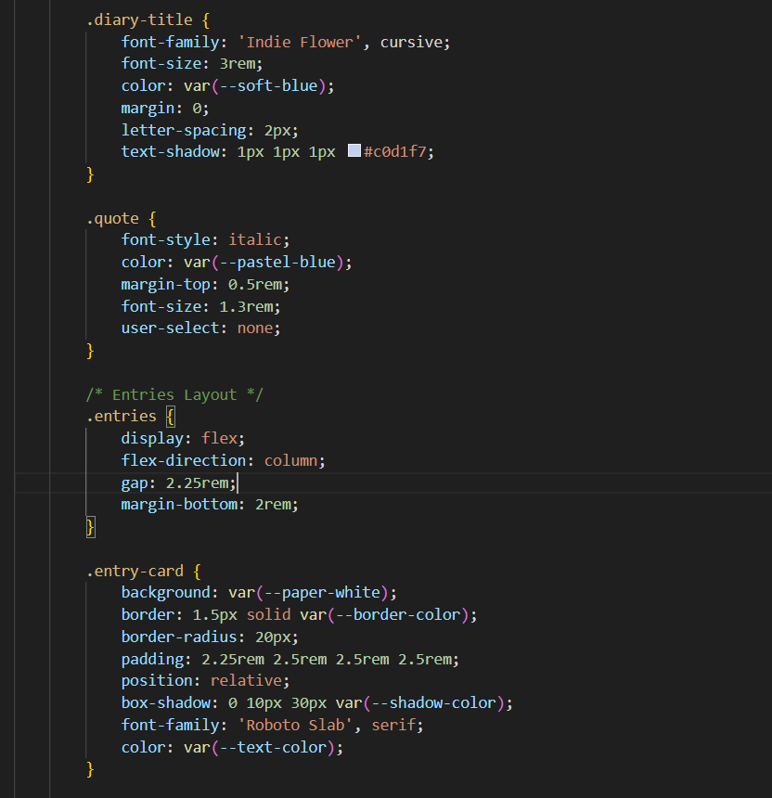

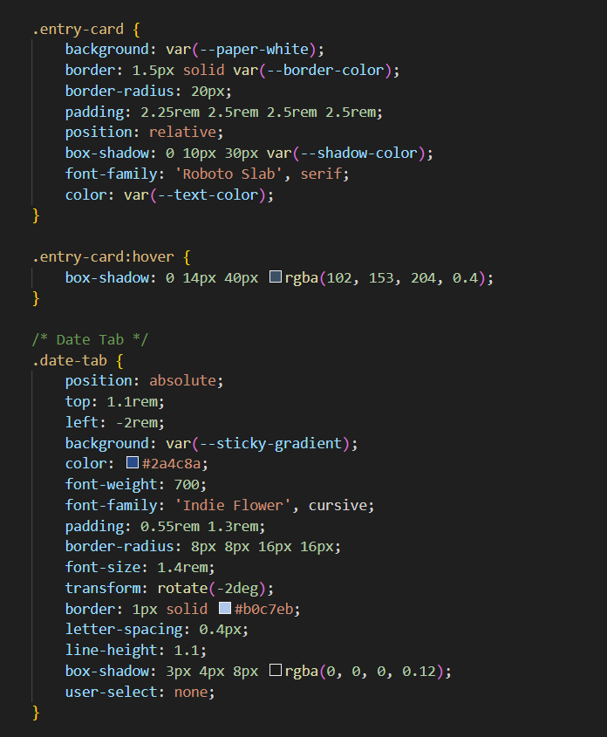

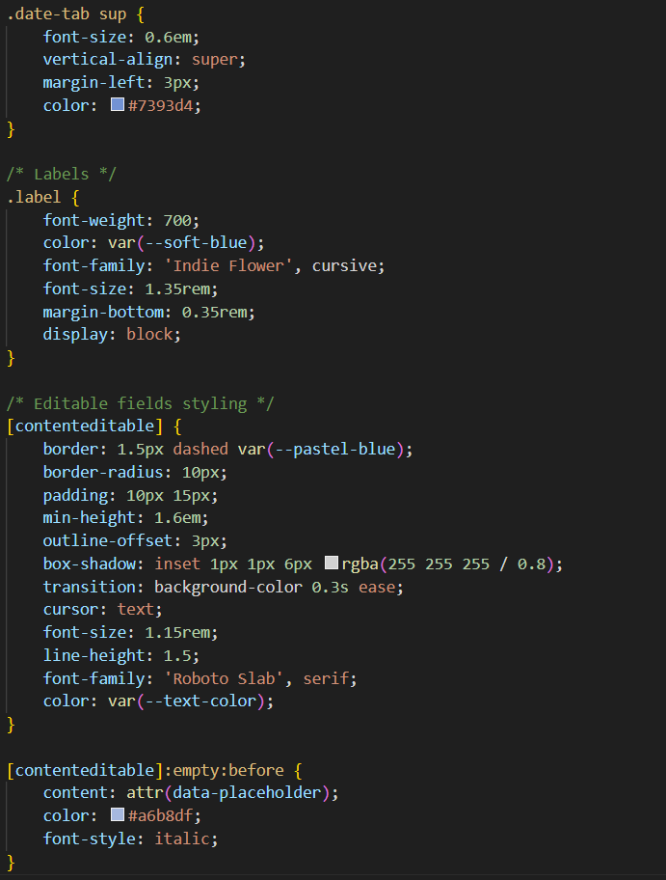

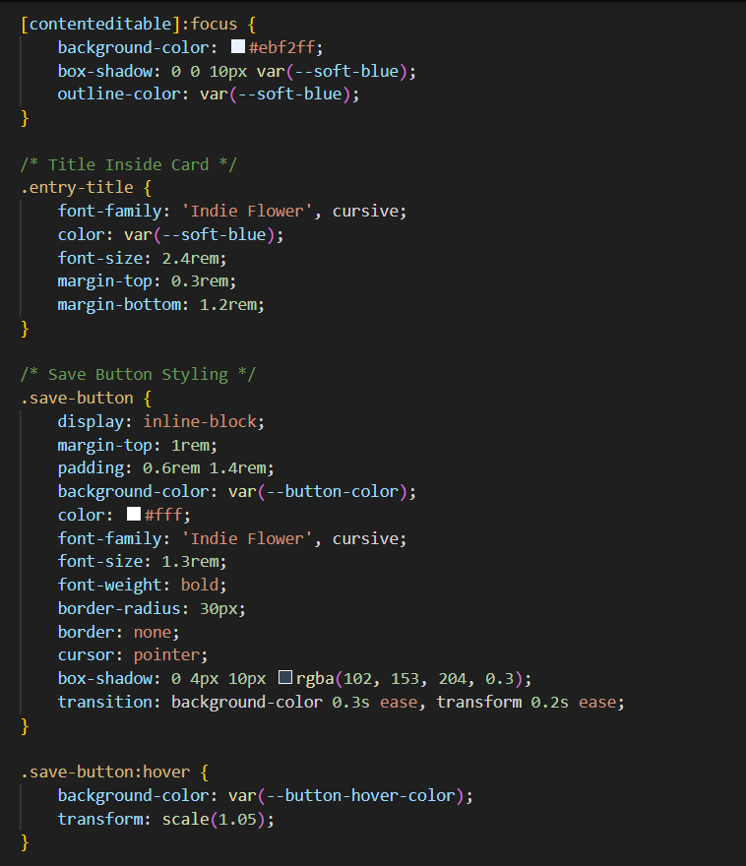

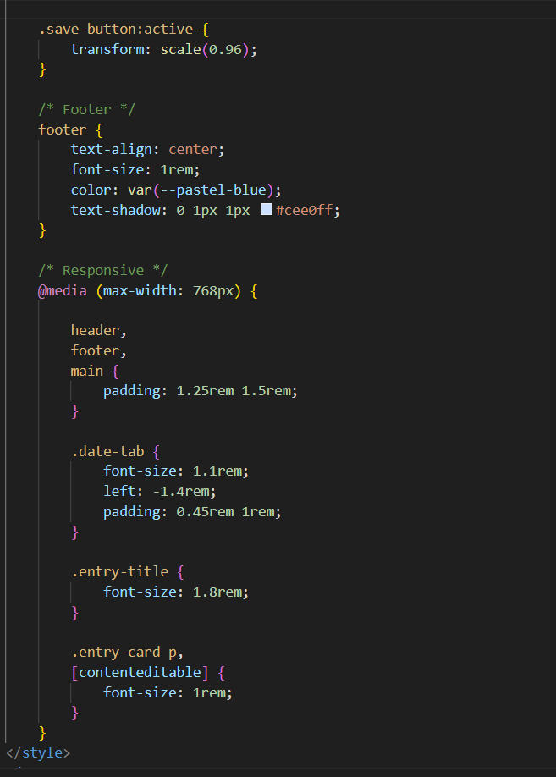

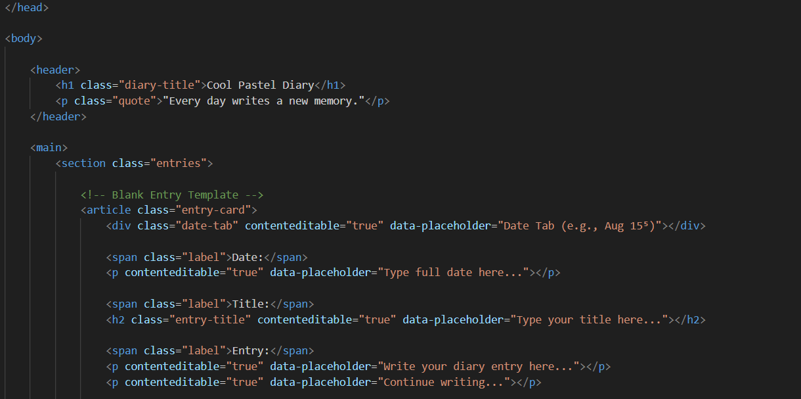

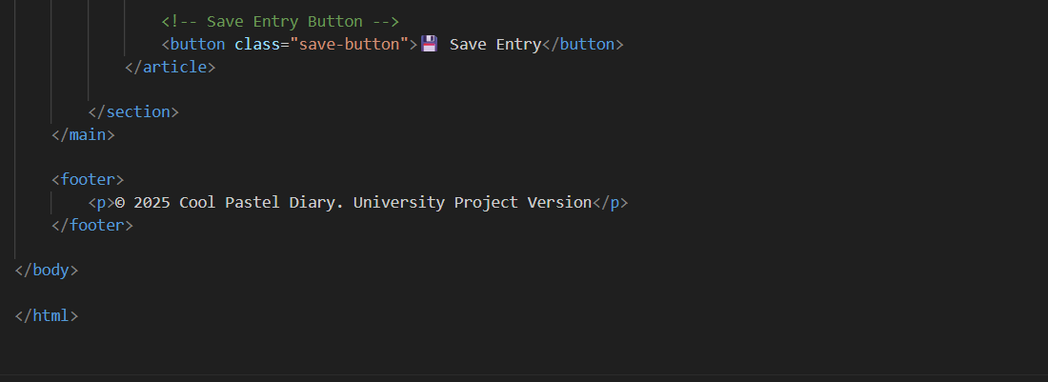

**13. Screenshots of Final Output**

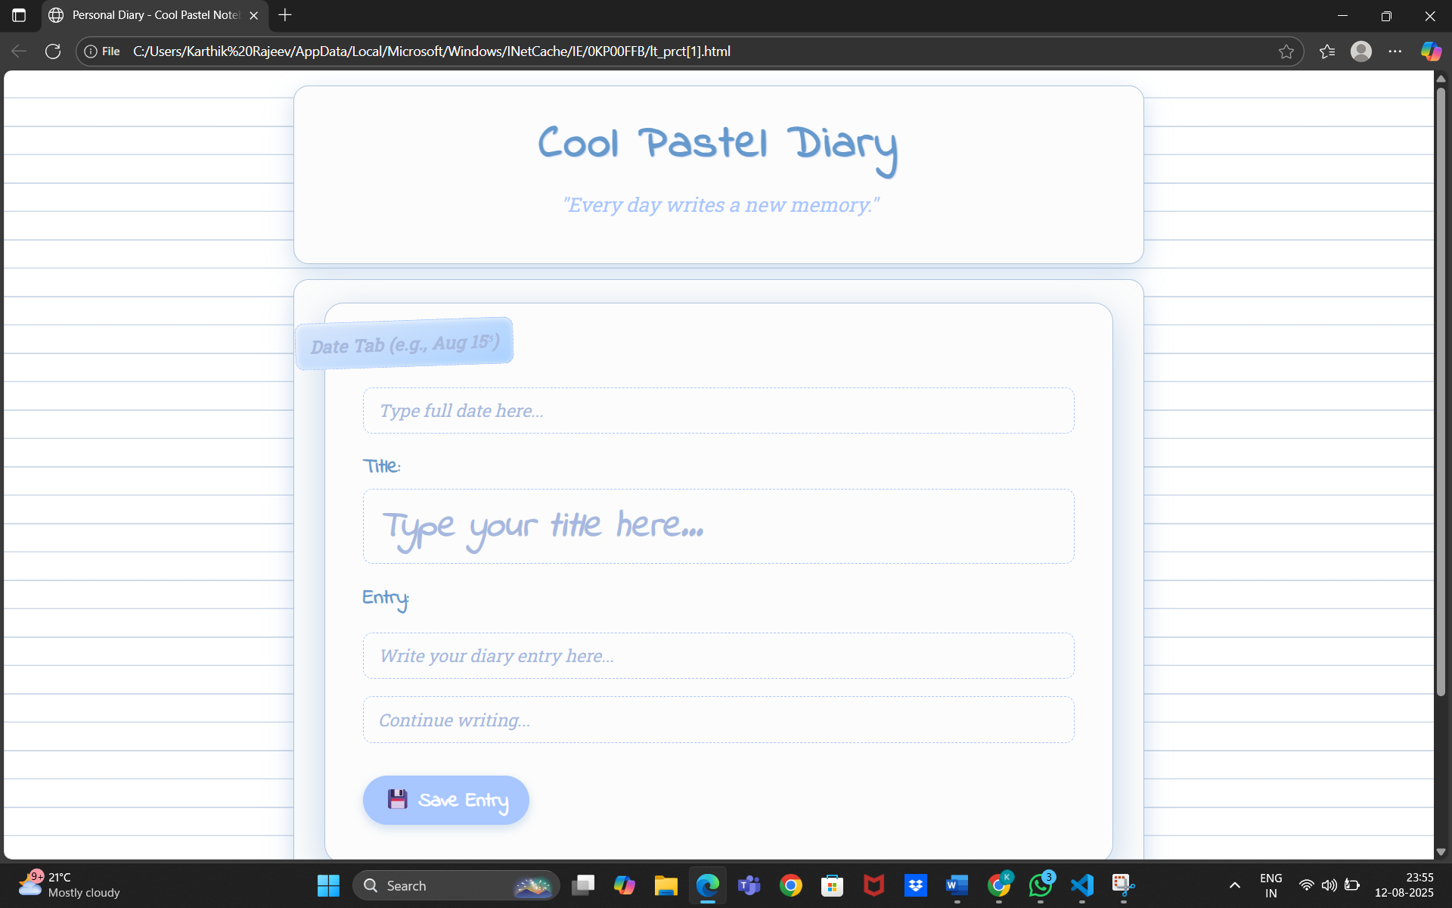

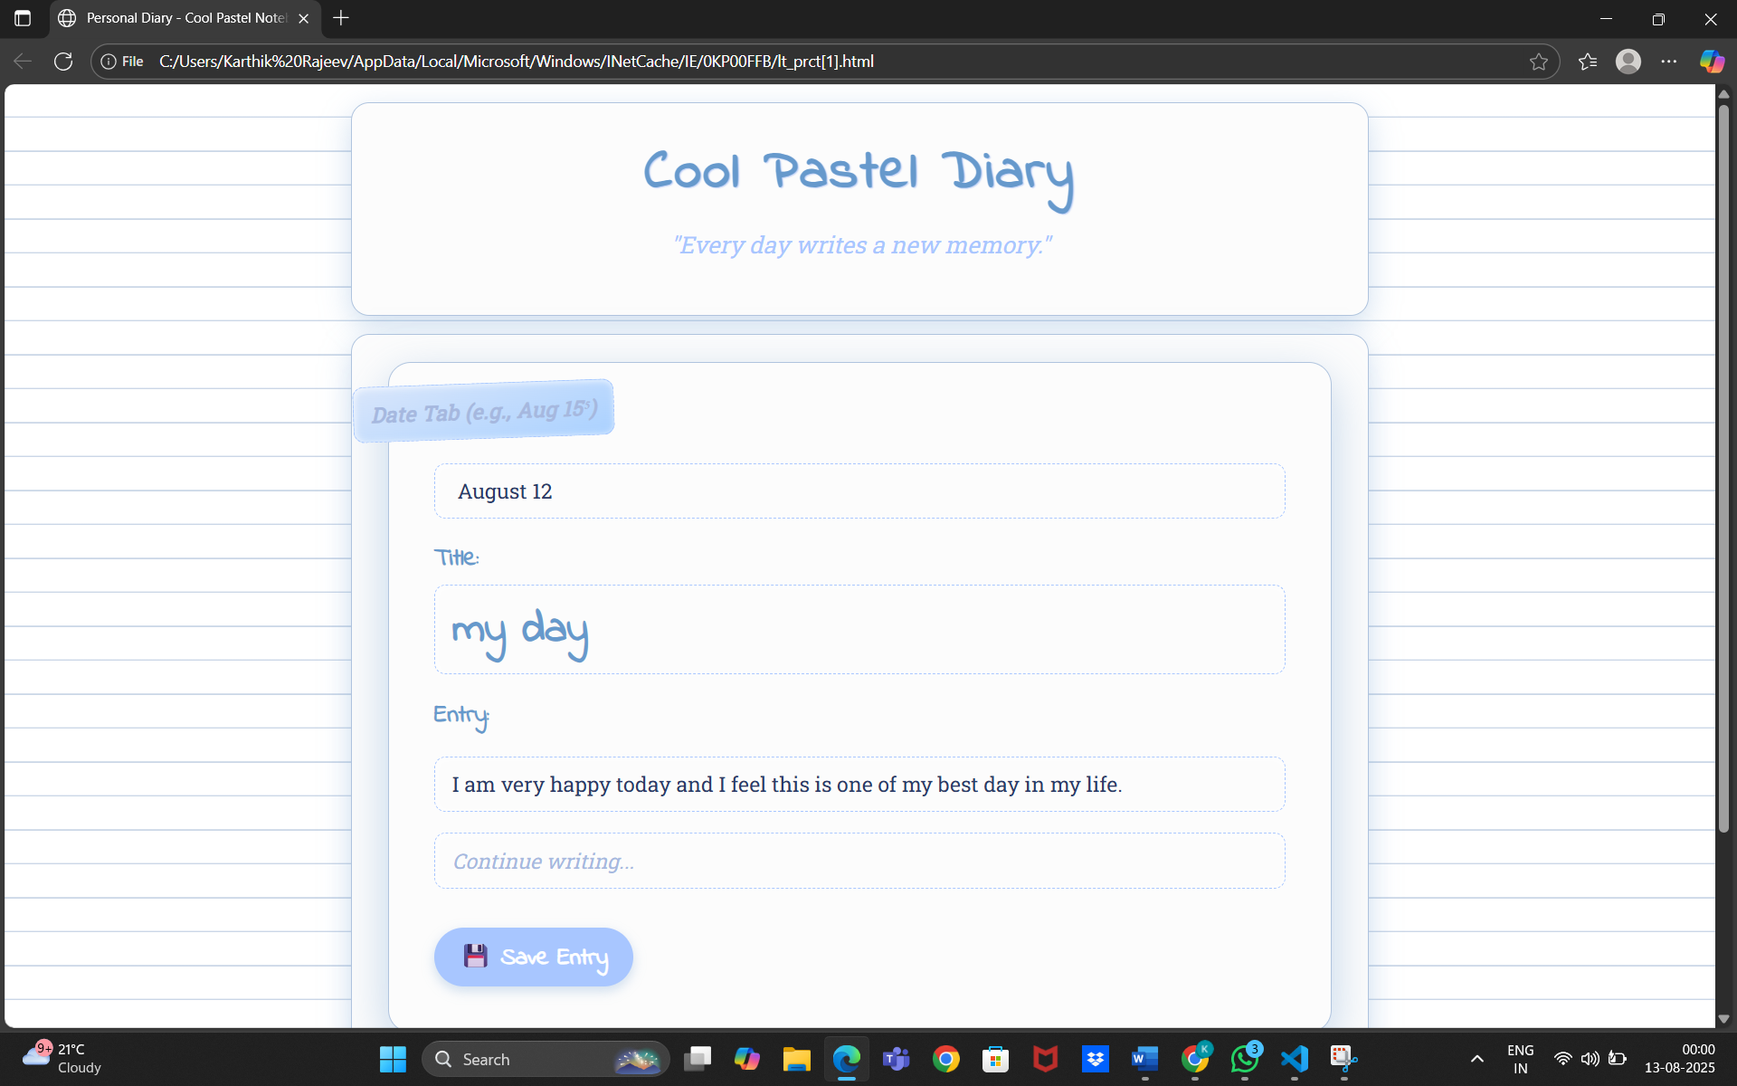

**13. Conclusion**

This diary-making project allowed me to design and develop a clean, responsive, and user-friendly digital diary interface using only HTML and CSS.

Through this project, I learned how to structure editable content areas effectively, manage layouts across multiple screen sizes, and maintain consistent typography for readability. Implementing a responsive design deepened my understanding of layout techniques such as Flexbox and media queries. Overall, this project strengthened my ability to create practical, aesthetically pleasing front-end interfaces that prioritize user experience.

**14. References**

* L&T LMS : https://learn.lntedutech.com/Landing/MyCourse